SQLMentor – SQL Mini Project Documentation

1. Project Title
SQLMentor: User Submission Analysis using SQL

2. Project Overview
SQLMentor is a mini SQL project designed to analyze user submission data from a competitive programming / learning platform. The project focuses on extracting meaningful insights from raw CSV data using SQL queries. It helps in understanding user performance, submission behavior, scoring trends, and leaderboard style analytics.
This project is suitable for beginners to intermediate learners who want hands-on practice with aggregate functions, grouping, filtering, date functions, and ranking queries in SQL.

3. Objectives of the Project
The main objectives of this project are:
- To practice real-world SQL querying on structured data
- To analyze user performance based on submissions and points
- To work with time-based data (daily and weekly analysis)
- To generate leaderboard style insights using SQL
- To strengthen concepts like GROUP BY, ORDER BY, COUNT, SUM, AVG, and window functions

4. Dataset Description
The dataset used in this project is provided in CSV format.
File Name:
user_sub_sql_mentor06nov.csv
Description:
The CSV file contains records of user submissions on the SQLMentor platform. Each row represents a single submission made by a user for a particular question.
Columns in the Dataset:
Column Name | Description
id | Unique identifier for each submission
user_id | Unique ID of the user
username | Name of the user
question_id | ID of the question attempted
points | Points earned for the submission
submitted_at | Date and time when the submission was made

5. Database Design
To store and analyze the CSV data, a relational table was created in MySQL.
Table Name:
user_submissions
Purpose of the Table:
The table stores all user submission records and serves as the base for all analytical SQL queries in this project.

6. Problem Statements
The following SQL queries were implemented as part of the project:
Q1. List all distinct users and their statistics
Requirement:
- Display each user’s name
- Total number of submissions
- Total points earned
Purpose: To get an overall performance summary of every user on the platform.
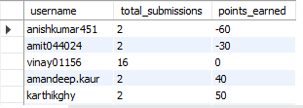

Q2. Calculate the daily average points for each user
Requirement:
- Compute the average points scored by each user per day
Purpose: To analyze daily performance consistency and scoring trends of users.
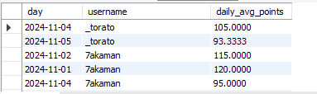

Q3. Find the top 3 users with the most positive submissions for each day
Requirement:
- Rank users daily based on positive (successful) submissions
- Display only the top 3 users per day
Purpose: To create a daily leaderboard and identify top performers.
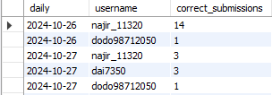

Q4. Find the top 5 users with the highest number of incorrect submissions
Requirement:
- Identify users with the most incorrect or zero-point submissions
- Display the top 5 users
Purpose: To analyze areas where users struggle and identify improvement needs.
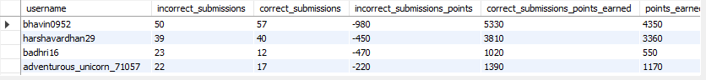

Q5. Find the top 10 performers for each week
Requirement:
- Aggregate user points on a weekly basis
- Rank users weekly and display top 10 performers
Purpose: To evaluate long-term performance and weekly consistency.
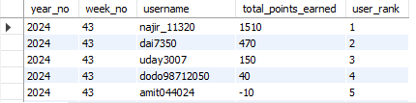

7. SQL Concepts Used
This project makes use of the following SQL concepts:
- SELECT, WHERE, GROUP BY, ORDER BY
- Aggregate functions: COUNT(), SUM(), AVG()
- Date and time functions
- Subqueries and Common Table Expressions (CTEs)
- Window functions such as RANK() / DENSE_RANK()
- Filtering grouped data using HAVING

8. Key Learnings
From this project, the following skills were strengthened:
- Writing analytical SQL queries
- Handling time-based data (daily and weekly analysis)
- Designing queries for leaderboard and ranking systems
- Understanding real-world data analysis requirements
- Improving query readability and optimization

9. Conclusion
The SQLMentor mini project provides hands-on exposure to real-world SQL analytics problems. By working with user submission data, this project demonstrates how SQL can be effectively used to extract insights, evaluate performance, and support data-driven decision-making.
This project is a strong foundation for roles such as Data Analyst, Business Analyst, and SQL Developer.

